**EE569 Introduction to Digital Image Processing**

**Homework Report #3**

**Name:** Boyang Xiao  **USC ID:** 3326730274  **Email:** [boyangxi@usc.edu](mailto:boyangxi@usc.edu)

# Problem 1: Geometric Image Modification

## Abstract and motivation

Geometric image modification is a kind of technique which modifies the shape and position of the image spatially. It provides the methods to reposition pixels within the image, relocating the pixels from their original coordinates to new coordinates to obtain the new image. Based on geometric image modification, many higher-level techniques can be implemented, such as features extraction, image augmentation and also image encoding.

Basic manipulation methods of geometric image modification include image translation, rotation, scaling and affine transformation. And with these basic manipulation methods, some advanced manipulation operations can be achieved, such as Image warping and 3D object warping. In this part of homework, one operation of image warping will be introduced and implemented.

## Approaches and procedures

The goal of this problem is to convert the provided images into star-shaped images shown in the homework requirements and then convert the images back to the normal shape. The warping operation is based on an assumed model shown in Figure 1.1 below.

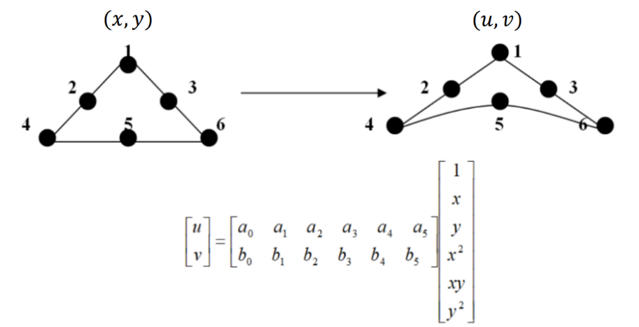

Figure 1.1: Image warping coefficient matrix model

In Figure1.1, (x,y) stands for the pixel coordinates on the original image and (u,v) stands for the corresponding pixel coordinates on the warped image. To do the image warping, a coefficient matrix is multiplied to the matrix made up with (x,y) coordinates. There are 12 unknown coefficients in the coefficient matrix and 6 pairs of control points have to be picked to calculate the coefficient matrix. The picked control points are also shown in the Figure 1.1. After the coefficient matrix is calculated, it can be applied to every pixel in the image to calculate their coordinates after the warping. And the output image can be rendered according to the coordinate mapping relation.

Since the warping patterns for the four sides of the original image rectangle are similar to each other except for the warping direction, the original image is segmented into 4 regions as shown in Figure 1.2 below. The coefficient matrices for each region are calculated individually from the control points picked from each region.

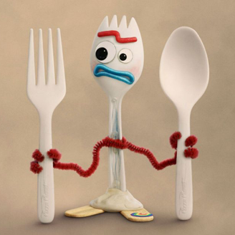

**Region**

**Region**

**Region**

**Region**

Figure 1.2 Segmentation of the image for warping according to each region

Therefore, the specific steps to do the warping algorithm **from a normal shape image to a star-shaped image** will be:

1. Segment the whole original image into four regions as shown in Figure1.2 and pick the control points for each region as shown in Figure 1.1.
2. Calculate the coefficient matrices for each region and apply the different coefficient matrices respectively to all the pixels in the four regions. A new matrix (let’s call it the ***position matrix***) should be obtained, which records the coordinates mapping relation from the original image to the warped image.
3. Every single coordinate pair (***coordinate 1***) saved in the *position matrix* are the pixel coordinates after the warping, and the index for this coordinates pair in the *position matrix* is this pixel’s original position (***coordinate 2***) in the original image. Therefore, to render the warped image, for every pixel that is located at the coordinate 1 should be filled with the gray-scale value of the pixel located at the coordinate 2 in the original image. After traversing the whole position matrix and the whole warped image should be obtained.

To do the **reverse spatial warping**, that is to warp an image from the star-shape back to the normal shape, the warping steps will be as following:

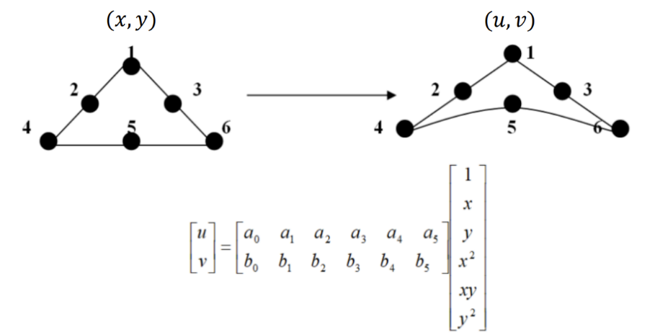

Figure 1.3 Control points selection in reverse warping operations.

1. Segment the whole original image into four regions as shown in Figure1.2. The control points selection should be inverse, as shown in Figure 1.3 below. The input points should be picked from the star-shaped image and the output points should be selected from the normal-shaped image.
2. The coefficient matrices are calculated for each region of the image. And then apply the coefficient matrices to all the pixel coordinates in the same regions respectively. A position matrix holding all the coordinates after the warping is obtained.
3. Since the reverse warping makes the points looser, if simply rendering the output image like what we did before, there will be many black dots gaps lying on the output image. Therefore, the bilinear interpolation should be applied to fill the gaps. To elaborate, if the output coordinate lies between the integer input coordinates, the output pixel gray-scale value should be calculated with bilinear interpolation from the four pixels on the four corners on the input image. After traversing all the pixels on the output image, the reversed image is obtained.

## Experiment results

The warped star-shaped images are shown in Figure 1.4. below:

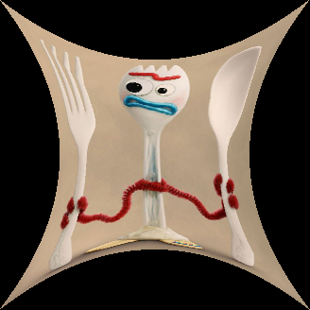 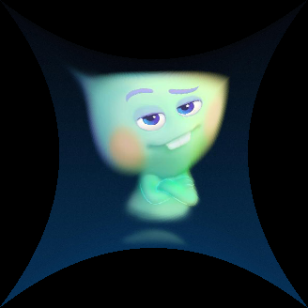

Figure 1.4 Warped star-shaped images.

The reverse warped images are shown in Figure 1.5 below:

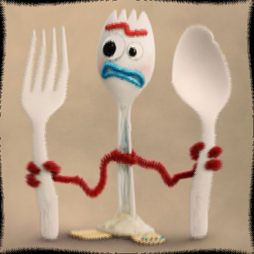 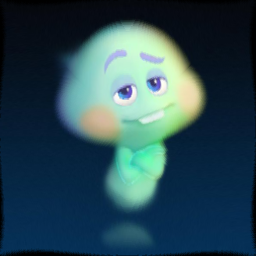

Figure 1.5 Recovered images using reverse warping.

## Discussions

Comparing to the original un-warped images, the recovered images have several kinds of distortions:

1. The recovered images are bent and twisted, especially in some areas that have straight shapes (such as the fork and the spoon in the Forky.raw image).
2. The recovered images have dark areas unfilled on the boundaries. The dark areas on the four sides are of the same pattern.
3. The recovered images are blurred.

The ***reasons*** for these distortions can be:

1. Since the model we choose is not optimized and the model is not linear, either, when applying the forwarding coefficient matrix first and then applying the reverse coefficient matrix, the results of this operation cannot be strictly the same as the original coordinates. As a result, the recovered images are bent and twisted because the pixels are dislocated.
2. As we know from above, the pixels can be dislocated since the model problems, the impact on the pixels lying on the boundaries can be the most. Some dark pixels can be relocated on the output image’s boundary areas after the reverse warping operation, which causes the dark areas on the recovered images.
3. When we fill in the blank gaps on the recovered images, we use the bilinear interpolation. So many pixels are actually predicted from the neighboring pixels and calculated from the averaging, but not directly obtained from the original pixel value. This step can make the output images to be blurred.